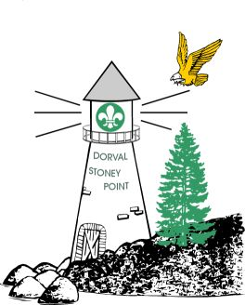
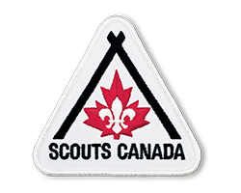

Badges
The following badges will be offered at camp. Pleasemark choices as

JUMP SCOUT PROGRAM
(3rd year)

CAMPING SKILLS 1-2

CAMPING SKILLS 3

TRAIL SKILLS 1-2

TRAIL SKILLS 3

EMERGENCY 1-2

EMERGENCY 3-4

PADDLING 1

PADDLING 2
-------------------------------------------
Age Level
1st year (7-8 yrs) 
2nd year (9 yrs) 
3rd year (10-11yrs) 
I CONSIDER MY CUB PHYSICALLY FIT TO ENGAGE IN CAMP ACTIVITIES AND TO THE BEST OF MY KNOWLEDGE, IS IN GOOD HEALTH. I GIVE PERMISSION FOR CAMP MEDICAL STAFF TO TREAT MY CUB IN CASE OF EMERGENCY AS REQUIRED. I GIVE PERMISSION FOR MY CUB TO ATTEND THE ABOVE MENTIONED CAMP.

________________________________________________________________________
SIGNATURE OF PARENT/GUARDIAN

Fees: $110___ T Shirt included (Payable to your Group or Pack) NON REFUNDABLE

We will be able to drive cubs in our car

T Shirt size Youth : M L
Men’s : S M L XL OR XXL
^{Please Check off the size} ^{required}
1
2
3

CUB Application and Medical Record

Name: _______________________________ Pack: _____________________

Tel. # at home: _____________________________Male/Female:__________

Medicare #: _______________________________ Expires: ______________

Address: _______________________________________________________

__________________________________________Photo Allowed: Yes /No

IN CASE OF EMERGENCY PLEASE NOTIFY:

NAME: __________________________________ Tel. _______________

OR : ____________________________________ Tel: ________________
Please list below any present medications and reasons for them.
(Attach Scouts Canada Physical Fitness form if necessary)

Allergies? Peanuts Shellfish Pork (religious)

Other (specify)__________________________________________________
________________________________________________________________
If required may we give your child Tylenol? YES NO
Parents' Comments:

_____________________________________________________________

Stoney Point - Dorval
Spring Cub Camp 2025
Camp Kinkora
May 30 to June 1

